This project is a national Health care expense program that generates Overall expenses and the Percentage of persons with an expense by age group in 2016.

It also shows the mean per person with an expense

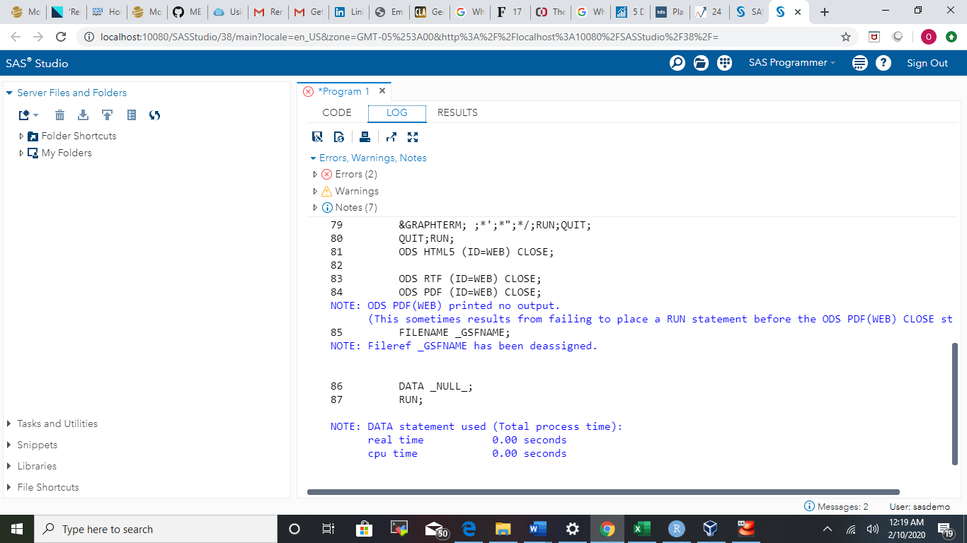

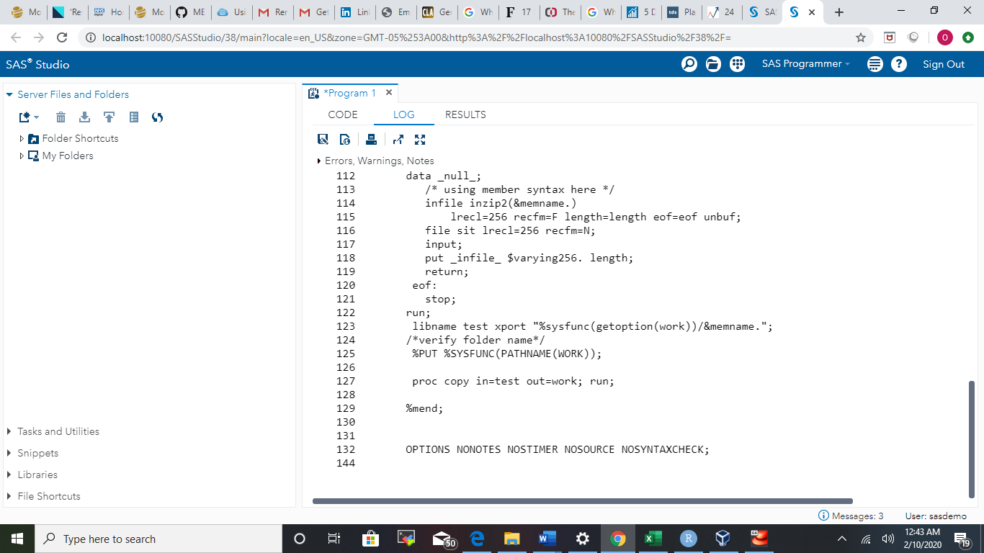

The above image shows macro downloads the .zip file from the MEPS website, unzips it, and loads the SAS transport file (.ssp) into memory.

The code to generate SAS summary statistics PROC MEANS MEAN STD MEDIAN KURTOSIS SKEWNESS MEDIAN Q1 Q3;

VAR;

RUN;

The code to calculate sample generate Hypothesis for a two-sample t test

**proc ttest** data=name;

class group; /* defines the grouping variable */

var var; /* variable whose means will be compared */

**run;**

|  |
| --- |
|  |
|  |
|  |  |
|  |  |
|  |  |
|  |  |
| Code |  |

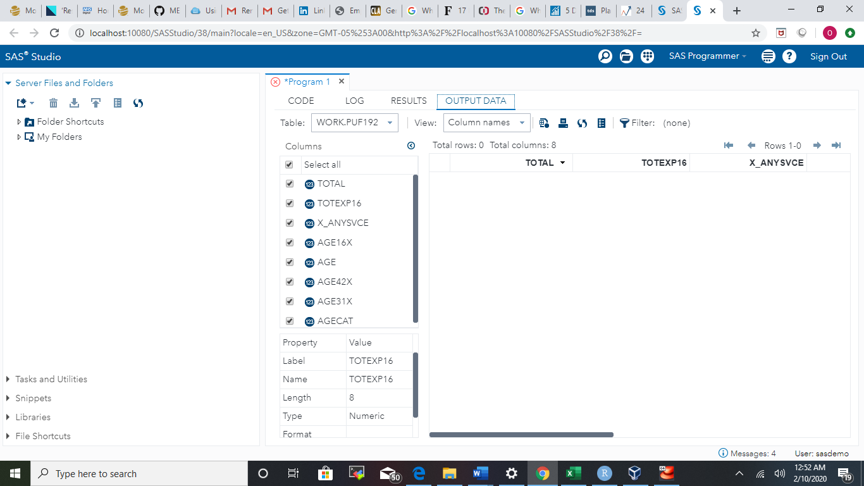

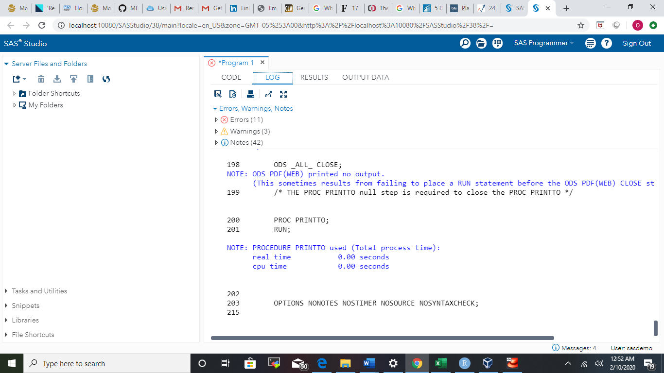

Above is the Error messages i got while running the dataset